STEPS to enrol for NCERT MOOCS courses on SWAYAM Portal

- Go to https://swayam.gov.in/
- Click on Register/Sign in 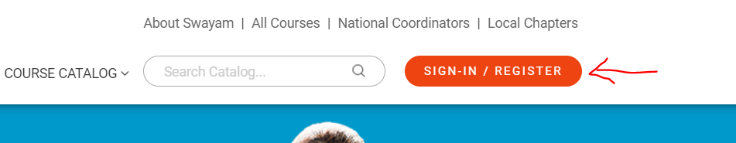
- Click on Sign-Up Now 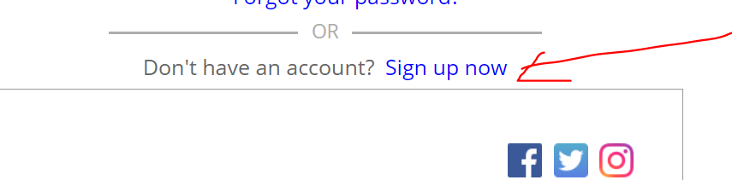
- Fill the details as asked (You will have to verify your mobile number through OTP)
- When asked about EMPLOYER DETAILS, Fill as below 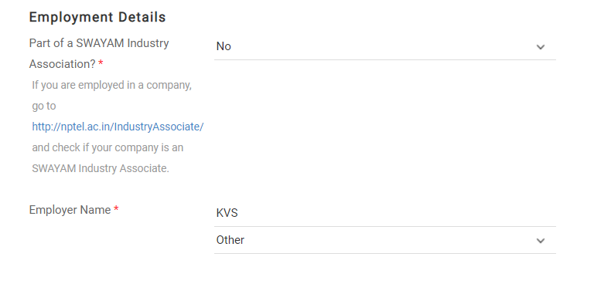
- For TEACHERS ONLY- Once you are login, search the course using course number – (TOTAL 5 courses)

Course Number | Course Name
211 | Secondary: Mathematics
212 | Secondary : Science and Technology
314 | Sr. Secondary: Biology
311 | Sr. Secondary: Mathematics
313 | Sr. Secondary: Chemistry
330 | Sr. Secondary: Computer
333 | Sr. Secondary: Environmental Science

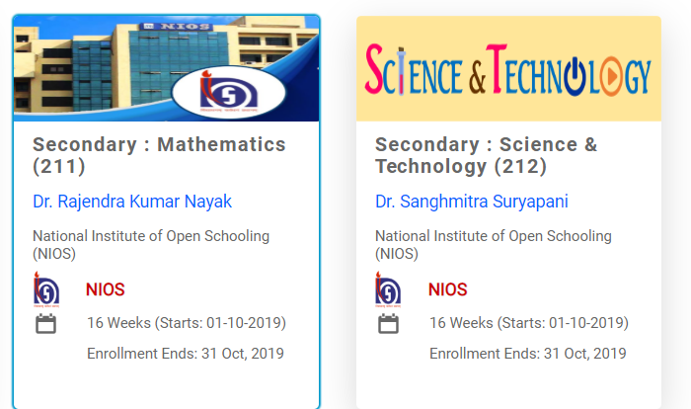

- FOR STUDENTS ONLY— Click on all courses, Select CATEGORY as ‘School’. There are 23 total courses for different subjects.

- Click on course and Click Join
- You will get the complete schedule of course and study materials.
- Enjoy Learning

